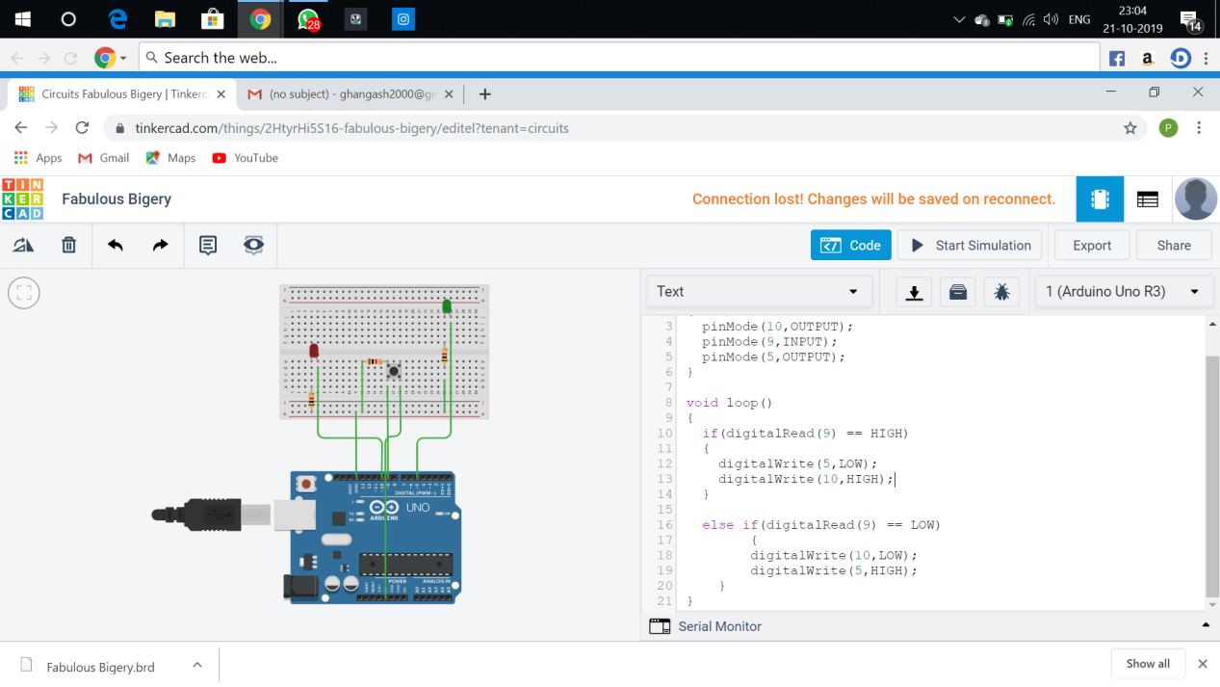

**Theory**

**Concept Used:**

Design a system for washing machines such that whenever it is filled, a Red LED turns on and if it is empty, a Green LED blinks once every 20 ms.

**Learning and Observations:**

**Following observations were recorded during the experiment:**

➢ The washing machine module used in the experiment has a arduino uno R3, 3 resistor of 1killo ohm, a green led, a red led and a push button.

➢ ARDUINO UNO can receive the input from the Module.

➢ The washing machine module has 3 resistor of 1killo ohm.

**Problems and Troubleshooting:**

The experiment was performed successfully without any problem.

Precautions:

The following precautions need to be considered while performing this

experiment:

➢ The connections of the USB in both the PC and the ARDUINO UNO board

should be snug.

➢ The USB ports of the PC and the ARDUINO UNO should be in a working

condition.

➢ The sketch should be logically and syntactically correct and germane to

the experiment that needs to be performed.

➢ The correct serial port should be selected that is the one through which

the ARDUINO UNO has been connected.

➢ Look for errors during compilation and upload of the executable to the

ARDUINO UNO.

➢ Do not open more than one instance of the ARDUINO IDE at a time.

➢ The washing machine module needs to be handled with care and proper voltage

should be supplied to it.

**Learning outcomes:**

The various learnings as the outcome of performing the above-mentioned

experiment are:

➢ Ability to identify and connect the module with the ARDUINO

through proper connections using a breadboard.